Spatial Autocorrelation

Nilupa Gunaratna, Yali Liu, Junyong Park

- Definition

Observations made at different locations may not be independent. For example, measurements made at nearby locations may be closer in value than measurements made at locations farther apart. This phenomenon is called spatial autocorrelation.

Spatial autocorrelation measures the correlation of a variable with itself through space.
Spatial autocorrelation can be positive or negative. Positive spatial autocorrelation occurs when similar values occur near one another. Negative spatial autocorrelation occurs when dissimilar values occur near one another.

2. Weight Matrix

To assess spatial autocorrelation, one first needs to define what is meant by two observations being close together, i.e., a distance measure must be determined. These distances are presented in weight matrix, which defines the relationships between locations where measurements were made. If data are collected at locations, then the weight matrix will be with zeroes on the diagonal.

The weight matrix can be specified in many ways:

- The weight for any two different locations is a constant.
- All observations within a specified distance have a fixed weight.
- K nearest neighbors have a fixed weight, and all others are zero.
- Weight is proportional to inverse distance, inverse distance squared, or inverse distance up to a specified distance.

Other weight matrices are possible. The weight matrix is often row-standardized, i.e., all the weights in a row sum to one. Note that the actual values in the weight matrix are up to the researcher.
3. Measures of Spatial Autocorrelation

Moran's I

Moran's I (Moran 1950) tests for global spatial autocorrelation for continuous data.

It is based on cross-products of the deviations from the mean and is calculated for observations on a variable at locations, as:

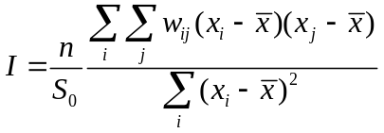,

where is the mean of the variable, 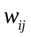 are the elements of the weight matrix, and 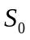 is the sum of the elements of the weight matrix: 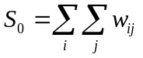.

Moran’s I is similar but not equivalent to a correlation coefficient. It varies from -1 to +1. In the absence of autocorrelation and regardless of the specified weight matrix, the expectation of Moran’s I statistic is 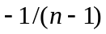, which tends to zero as the sample size increases. For a row-standardized spatial weight matrix, the normalizing factor equals (since each row sums to 1), and the statistic simplifies to a ratio of a spatial cross product to a variance. A Moran’s I coefficient larger than indicates positive spatial autocorrelation, and a Moran’s I less than indicates negative spatial autocorrelation. The variance is:

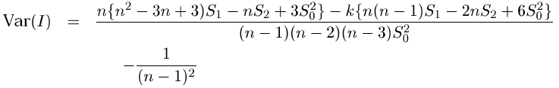
where 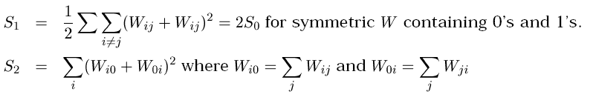
- Geary's C
Geary’s C statistic (Geary 1954) is based on the deviations in responses of each observation with one another:
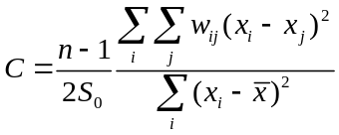.
Geary’s C ranges from 0 (maximal positive autocorrelation) to a positive value for high negative autocorrelation. Its expectation is 1 in the absence of autocorrelation and regardless of the specified weight matrix (Sokal & Oden 1978). If the value of Geary’s C is less than 1, it indicates positive spatial autocorrelation. The variance is: 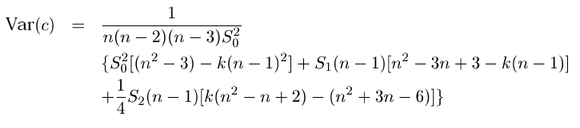
where 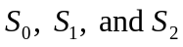 are the same as in Moran’s I.
- Comparison of Moran’s I and Geary’s C
Moran’s I is a more global measurement and sensitive to extreme values of , whereas Geary’s C is more sensitive to differences in small neighborhoods. In general, Moran’s I and Geary’s C result in similar conclusions. However, Moran’s I is preferred in most cases since Cliff and Ord (1975, 1981) have shown that Moran’s I is consistently more powerful than Geary’s C.
- SAS example
There is no straightforward way to calculate Moran’s I and Geary’s C using SAS. One source of code using proc iml can be found at the website of E.B. Moser at the Department of Experimental Statistics, Louisiana State University (http://www.stat.lsu.edu/faculty/moser/spatial/spatial.html).

In his example, a quantitative response variable, X, is measured at 16 locations indexed by I.

DATA RESPONSE;
INPUT I X @@;
LIST;
CARDS;
1 4 2 4 3 4 4 4 5 4 6 -2 7 -1 8 5 9 4 10 -1 11 -2 12 5 13 5 14 5 15 5 16 5
;

The weight matrix should therefore be 16 × 16. We assume the matrix is symmetric (the relationship between locations i and j is the same as the relationship between locations j and i) and specify all nonzero relationships in the data step below. I and J are the indices for pairs of locations, and WT is the weight for those pairs.

DATA WEIGHTS;
INPUT I J WT @@;
LIST;
CARDS;
1 6 1 2 6 1 2 7 1 3 6 1 3 7 1 4 7 1 5 6 1 5 10 1 6 9 1 7 8 1 7 12 1 8 11 1 9 10 1 10 13 1 10 14 1 10 15 1 11 14 1 11 15 1 11 16 1 11 12 1
;

Proc IML will be used for the computations:

PROC IML; /* SAS INTERACTIVE MATRIX LANGUAGE */

START LOADDATA;
USE RESPONSE VAR {X};
READ ALL;
CLOSE RESPONSE;
N=NROW(X);
W=J(N,N,0); /* INITIALIZE WEIGHT MATRIX TO ZEROS */
USE WEIGHTS VAR {I J WT};
READ ALL;
/* PLACE WEIGHTS INTO THE WEIGHT MATRIX */
DO K=1 TO NROW(I);
W[I[K],J[K]]=WT[K];
W[J[K],I[K]]=WT[K]; /* ASSUMING SYMMETRY IN WEIGHTS */
END;
/* DROP THE I J AND WT MATRICES */
FREE I J K WT;
PRINT / 'INITIAL DATA ' ,, 'RESPONSE',X,, 'WEIGHTS', W[FORMAT=3.0];
/* $$$ THE FORMAT MAY NEED TO BE CHANGED IF $$$ */
/* $$$ FRACTIONAL WEIGHTS ARE TO BE USED. $$$ */
FINISH;

START STATS;
XBAR=X[+]/N;
Z=X-REPEAT(XBAR,N,1);
ZSQ=Z`*Z;
XVAR=ZSQ/(N-1);
VMRATIO=XVAR/XBAR;
Z2=Z#Z; Z4=Z2`*Z2;
B2=N*Z4/ZSQ**2; /* KURTOSIS */
FREE Z2 Z4;
SUMW=0; S1=0;
DO K=1 TO N;
DO J=1 TO N;
IF K <> J THEN
DO;
SUMW=SUMW + W[K,J];
S1=S1 + (W[K,J]+W[J,K])**2;
END;
END;
END;
S1=S1/2;
S2=W[,+]+W[+,]`;
S2=S2`*S2;
SUMW2=SUMW*SUMW;
TEMP=N||XBAR||XVAR||VMRATIO||B2;
RNAME={" "};
CNAME={" N" " XBAR" "VARIANCE" "V/M RATIO" "KURTOSIS"};
PRINT / 'SUMMARY STATISTICS ' TEMP[ROWNAME=RNAME COLNAME=CNAME];
FREE XBAR XVAR VMRATIO K J RNAME CNAME TEMP;
FINISH;

START AUTOCORR;
I=0; C=0;
DO K=1 TO N;
DO J=1 TO N;
IF K <> J THEN
DO;
I = I + W[K,J] * Z[K]*Z[J];
C = C + W[K,J] * (X[K]-X[J])**2;
END;
END;
END;
I=(N/SUMW)*(I/ZSQ);
C=((N-1)/(2*SUMW))*(C/ZSQ);
FREE K J;
FINISH;

START AUTOSTAT;
RNAME={" "}; CNAME={"I " "C "};
TEMP=I||C;
PRINT ,, 'SPATIAL AUTOCORRELATION STATISTICS'
TEMP[ROWNAME=RNAME COLNAME=CNAME];
FREE RNAME CNAME TEMP;
FINISH; /* AUTOSTAT */

START TESTOFI;
EXPECT=1/(1.0-N);
RNAME={" "}; CNAME={" E(I) " "OBSERVED"};
TEMP=EXPECT||I;
PRINT "TEST OF I", "EXPECTED AND OBSERVED VALUES"
TEMP[ROWNAME=RNAME COLNAME=CNAME];
VAR=((N**2*S1-N*S2+3*SUMW2)/(SUMW2*N**2-1))-EXPECT**2;
ZZ=(I-EXPECT)/SQRT(VAR);
P=1-PROBNORM(ABS(ZZ));
CNAME={"VARIANCE" " Z " " P>|Z| "};
TEMP=VAR||ZZ||P;
PRINT 'TEST BASED ON NORMALITY:'
TEMP[ROWNAME=RNAME COLNAME=CNAME];
VAR=(N*((N**2-3*N+3)*S1-N*S2+3*SUMW2)-
B2*((N**2-N)*S1-2*N*S2+6*SUMW2))/
((N-1)*(N-2)*(N-3)*SUMW2) - EXPECT**2;
ZZ=(I-EXPECT)/SQRT(VAR);
P=1-PROBNORM(ABS(ZZ));
TEMP=VAR||ZZ||P;
PRINT 'TEST BASED ON RANDOMIZATION:'
TEMP[ROWNAME=RNAME COLNAME=CNAME];
FREE EXPECT VAR ZZ P RNAME CNAME TEMP;
FINISH;
START TESTOFC;
EXPECT=1.0;
RNAME={" "}; CNAME={" E(C) " "OBSERVED"};
TEMP=EXPECT||C;
PRINT "TEST OF C", "EXPECTED AND OBSERVED VALUES"
TEMP[ROWNAME=RNAME COLNAME=CNAME];
VAR=((2*S1+S2)*(N-1)-4*SUMW2)/(2*(N+1)*SUMW2);
ZZ=(C-EXPECT)/SQRT(VAR);
P=1-PROBNORM(ABS(ZZ));
CNAME={"VARIANCE" " Z " " P>|Z| "};
TEMP=VAR||ZZ||P;
PRINT 'TEST BASED ON NORMALITY:'
TEMP[ROWNAME=RNAME COLNAME=CNAME];
/* ZZ AND P BELOW ARE TEMPORARIES */
ZZ=(N-1)*S1*(N**2-3*N+3-(N-1)*B2)-(N-1)/4*S2;
P=(N**2+3*N-6-(N**2-N+2)*B2)+SUMW2*(N**2-3-(N-1)**2*B2);
VARC=ZZ*P/(N*(N-2)*(N-3)*SUMW2);
ZZ=(C-EXPECT)/SQRT(VAR);
P=1-PROBNORM(ABS(ZZ));
TEMP=VAR||ZZ||P;
PRINT 'TEST BASED ON RANDOMIZATION:'
TEMP[ROWNAME=RNAME COLNAME=CNAME];
FREE EXPECT VAR ZZ P RNAME CNAME TEMP;
FINISH;

RESET NOLOG NONAME FW=10;
RUN LOADDATA; /* READ THE DATA INTO THE MATRICES */
RUN STATS; /* COMPUTE SUMMARY STATISTICS */
RUN AUTOCORR; /* COMPUTE AUTOCORRELATION STATS. */
RUN AUTOSTAT; /* PRINT COMPUTED STATS. */
RUN TESTOFI; /* COMPUTE TESTS OF I */
RUN TESTOFC; /* COMPUTE TESTS OF C */

QUIT; /* DONE WITH SAS/IML */

The weight matrix looks like this:

WEIGHTS
0 0 0 0 0 1 0 0 0 0 0 0 0 0 0 0
0 0 0 0 0 1 1 0 0 0 0 0 0 0 0 0
0 0 0 0 0 1 1 0 0 0 0 0 0 0 0 0
0 0 0 0 0 0 1 0 0 0 0 0 0 0 0 0
0 0 0 0 0 1 0 0 0 1 0 0 0 0 0 0
1 1 1 0 1 0 0 0 1 0 0 0 0 0 0 0
0 1 1 1 0 0 0 1 0 0 0 1 0 0 0 0
0 0 0 0 0 0 1 0 0 0 1 0 0 0 0 0
0 0 0 0 0 1 0 0 0 1 0 0 0 0 0 0
0 0 0 0 1 0 0 0 1 0 0 0 1 1 1 0
0 0 0 0 0 0 0 1 0 0 0 1 0 1 1 1
0 0 0 0 0 0 1 0 0 0 1 0 0 0 0 0
0 0 0 0 0 0 0 0 0 1 0 0 0 0 0 0
0 0 0 0 0 0 0 0 0 1 1 0 0 0 0 0
0 0 0 0 0 0 0 0 0 1 1 0 0 0 0 0
0 0 0 0 0 0 0 0 0 0 1 0 0 0 0 0

The “AUTOSTAT” module gives the estimates of Moran’s I and Geary’s C:

I C
SPATIAL AUTOCORRELATION STATISTICS -0.9642857 2.44419643

The “TESTOFI” module gives:

E(I) OBSERVED
EXPECTED AND OBSERVED VALUES -0.0666667 -0.9642857

VARIANCE Z P>|Z|
TEST BASED ON NORMALITY: 0.0360244 -4.7292651 1.12667E-6

VARIANCE Z P>|Z|
TEST BASED ON RANDOMIZATION: 0.0368859 -4.6737112 1.47903E-6

The “TESTOFC” module gives:

E(C) OBSERVED
EXPECTED AND OBSERVED VALUES 1 2.44419643

VARIANCE Z P>|Z|
TEST BASED ON NORMALITY: 0.07647059 5.22250725 8.82583E-8

VARIANCE Z P>|Z|
TEST BASED ON RANDOMIZATION: 0.07647059 5.22250725 8.82583E-8

Note the p-values calculated by “TESTOFI” and “TESTOFC” are one-sided. There may be a cause for concern in “TESTOFC”, as it calculated the same variance for the two tests under normality and randomization assumptions.
4. Semivariogram
- Definition
Semivariance is also an autocorrelation statistic defined as:
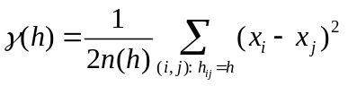
where 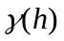 is the semivariance for distance class , 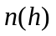 is the total number of pairs of values at distance , and 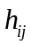 is the distance between locations and .

It is unlikely that any actual pair of locations would exactly have the distance of . It is common to consider a range of distances,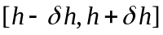, to group pairs for a single term in the expression for and to modify accordingly.

The semivariogram (variogram) is a plot of semivariance against distance between pairs. The plot values should increase as distance increases until they reach a plateau. This is because observations that are close together should be more similar than points that are widely separated. The plateau on the Y axis is called the “sill”, and the distance to the plateau on the x axis is called the “range”. It is a way to get an estimate of the general range of spatial dependence, which can be fitted to the plot, and this model can be used as a model for the spatial dependence, for interpolation.
- Theoretical Semivariogram Models
There are many types of theoretical semivariogram models. Some commonly used models are given below:

  - Spherical model: this is only valid for 1-3 dimensions. The equation is:

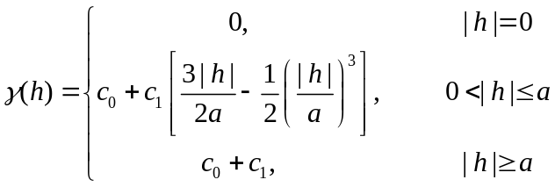

where 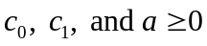.

  - Exponential model: this is valid for all dimensions with formula:

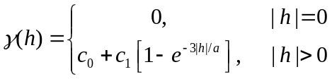

where .

  - Gaussian model: this is valid for all dimensions with formula:

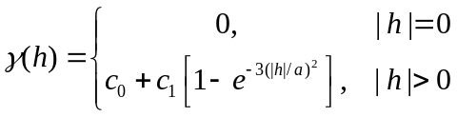

where .

  - Power model: this is valid for all dimensions with formula:

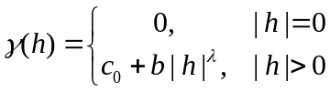

where 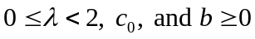. This model is linear model when 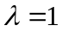.

Figure 1 illustrates the semivariograms for these models when 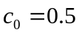, 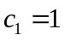, 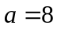, and 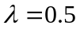. The spherical model reaches the sill,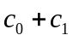, at 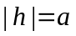 and looks nearly linear at small lags. The exponential and Gaussian models reach the same sill only asymptotically as 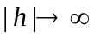. The exponential model has a similar shape to the spherical model but reaches the sill more quickly. The Gaussian is useful when the data have very high spatial correlation between two close points. It has an S-shape. The power model does not reach a sill and the shape depends on the parameter. It is appropriate when the data show a long-range correlation. If the semivariogram does not seem to follow any of the standard structures, it is possible to combine structures to obtain something with characteristics of more than one standard structure. This is called a “nested structure”.

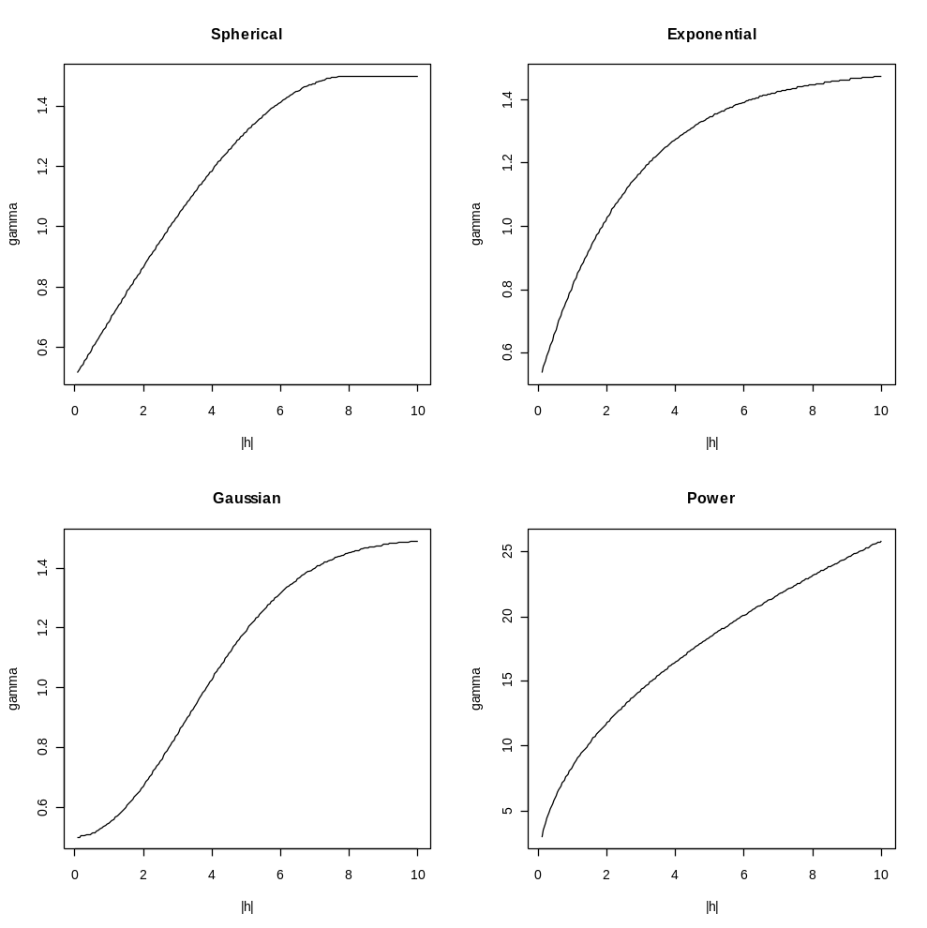
Figure 1. Semivariogram for different models
- SAS Example for Semivariogram
In SAS, proc variogram computes the sample semivariogram, from which a suitable theoretical semivariogram can be found visually. The goal here is often to predict values of the measured variable at unsampled locations.

The following example is taken from the SAS Version 8 online help (http://v8doc.sas.com/sashtml/).

Data were simulated to represent coal seam thickness measurements taken over an approximately square area:

data thick;
input east north thick @@;
datalines;
0.7 59.6 34.1 2.1 82.7 42.2 4.7 75.1 39.5
4.8 52.8 34.3 5.9 67.1 37.0 6.0 35.7 35.9
6.4 33.7 36.4 7.0 46.7 34.6 8.2 40.1 35.4
13.3 0.6 44.7 13.3 68.2 37.8 13.4 31.3 37.8
17.8 6.9 43.9 20.1 66.3 37.7 22.7 87.6 42.8
23.0 93.9 43.6 24.3 73.0 39.3 24.8 15.1 42.3
24.8 26.3 39.7 26.4 58.0 36.9 26.9 65.0 37.8
27.7 83.3 41.8 27.9 90.8 43.3 29.1 47.9 36.7
29.5 89.4 43.0 30.1 6.1 43.6 30.8 12.1 42.8
32.7 40.2 37.5 34.8 8.1 43.3 35.3 32.0 38.8
37.0 70.3 39.2 38.2 77.9 40.7 38.9 23.3 40.5
39.4 82.5 41.4 43.0 4.7 43.3 43.7 7.6 43.1
46.4 84.1 41.5 46.7 10.6 42.6 49.9 22.1 40.7
51.0 88.8 42.0 52.8 68.9 39.3 52.9 32.7 39.2
55.5 92.9 42.2 56.0 1.6 42.7 60.6 75.2 40.1
62.1 26.6 40.1 63.0 12.7 41.8 69.0 75.6 40.1
70.5 83.7 40.9 70.9 11.0 41.7 71.5 29.5 39.8
78.1 45.5 38.7 78.2 9.1 41.7 78.4 20.0 40.8
80.5 55.9 38.7 81.1 51.0 38.6 83.8 7.9 41.6
84.5 11.0 41.5 85.2 67.3 39.4 85.5 73.0 39.8
86.7 70.4 39.6 87.2 55.7 38.8 88.1 0.0 41.6
88.4 12.1 41.3 88.4 99.6 41.2 88.8 82.9 40.5
88.9 6.2 41.5 90.6 7.0 41.5 90.7 49.6 38.9
91.5 55.4 39.0 92.9 46.8 39.1 93.4 70.9 39.7
94.8 71.5 39.7 96.2 84.3 40.3 98.2 58.2 39.5
;

A scatterplot of the sampled locations is below. Note that if these data are intended for prediction, the sampled locations should be fairly evenly distributed across the area of interest.

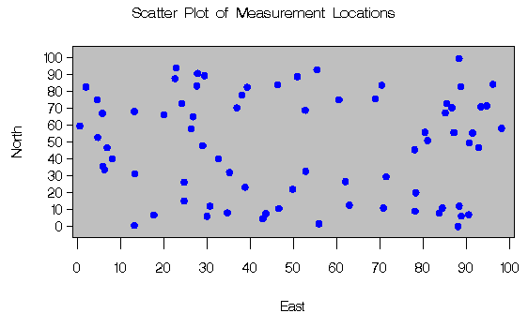

The next step is to create a “surface plot” of the measured variable (thickness). Any apparent trend must be removed before estimating the semivariogram model.

proc g3d data=thick;
title 'Surface Plot of Coal Seam Thickness';
scatter east*north=thick / xticknum=5 yticknum=5
grid zmin=20 zmax=65;
label east = 'East'
north = 'North'
thick = 'Thickness'
;
run;
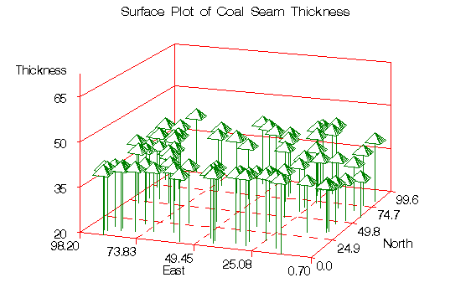

To compute a variogram, LAGDISTANCE (width of distance intervals) and MAXLAGS (number of intervals) must be determined. Reasonable values may be found using the following approach:

proc variogram data=thick outdistance=outd;
compute novariogram;
coordinates xc=east yc=north;
var thick;
run;

title 'OUTDISTANCE= Data Set Showing Distance Intervals';
proc print data=outd;
run;

data outd; set outd;
mdpt=round((lb+ub)/2,.1);
label mdpt = 'Midpoint of Interval';
run;

axis1 minor=none;
axis2 minor=none label=(angle=90 rotate=0);
title 'Distribution of Pairwise Distances';
proc gchart data=outd;
vbar mdpt / type=sum sumvar=count discrete frame
cframe=ligr gaxis=axis1 raxis=axis2 nolegend;
run;

Data set showing distance intervals:

Obs VARNAME LAG LB UB COUNT PER
1 thick 0 0.000 6.969 45 0.01622
2 thick 1 6.969 20.907 263 0.09477
3 thick 2 20.907 34.845 383 0.13802
4 thick 3 34.845 48.783 436 0.15712
5 thick 4 48.783 62.720 495 0.17838
6 thick 5 62.720 76.658 525 0.18919
7 thick 6 76.658 90.596 412 0.14847
8 thick 7 90.596 104.534 179 0.06450
9 thick 8 104.534 118.472 35 0.01261
10 thick 9 118.472 132.410 2 0.00072
11 thick 10 132.410 146.348 0 0.00000

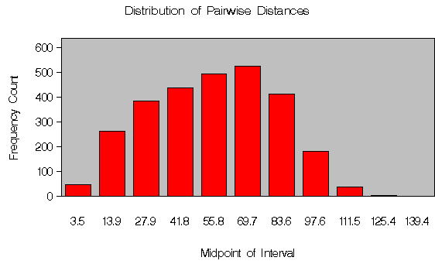

In general, it is desirable to have a small value for LAGDISTANCE. However, SAS says a rule of thumb used in computing sample semivariograms is to use at least 30 point pairs in computing a single value of the empirical or experimental semivariogram. The code below uses NHCLASSES=20, which leads to enough points in all but lag 0. The length of the lag 1 interval (rounded to the nearest integer) will be used as the LAGDISTANCE.

proc variogram data=thick outdistance=outd;
compute nhc=20 novariogram;
coordinates xc=east yc=north;
var thick;
run;

title 'OUTDISTANCE= Data Set Showing Distance Intervals';
proc print data=outd;
run;

data outd; set outd;
mdpt=round((lb+ub)/2,.1);
label mdpt = 'Midpoint of Interval';
run;

axis1 minor=none;
axis2 minor=none label=(angle=90 rotate=0);
title 'Distribution of Pairwise Distances';
proc gchart data=outd;
vbar mdpt / type=sum sumvar=count discrete frame
cframe=ligr gaxis=axis1 raxis=axis2 nolegend;
run;

Now, plot a standard and robust semivariogram:

proc variogram data=thick outv=outv;
compute lagd=7 maxlag=10 robust;
coordinates xc=east yc=north;
var thick;
run;

title 'OUTVAR= Data Set Showing Sample Variogram Results';
proc print data=outv label;
var lag count distance variog rvario;
run;

data outv2; set outv;
vari=variog; type = 'regular'; output;
vari=rvario; type = 'robust'; output;
run;

title 'Standard and Robust Semivariogram for Coal Seam
Thickness Data';
proc gplot data=outv2;
plot vari*distance=type / frame cframe=ligr vaxis=axis2
haxis=axis1;
symbol1 i=join l=1 c=blue /* v=star */;
symbol2 i=join l=1 c=yellow /* v=square */;
axis1 minor=none
label=(c=black 'Lag Distance') /* offset=(3,3) */;
axis2 order=(0 to 9 by 1) minor=none
label=(angle=90 rotate=0 c=black 'Variogram')
/* offset=(3,3) */;
run;

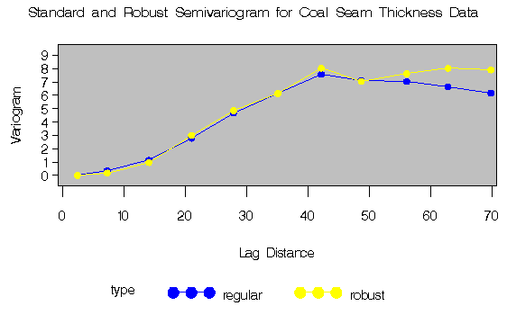
The increasingly rapid rise from the origin suggests that a Gaussian model may be appropriate (note this is based on visual inspection).
Trial and error reveals that a scale of c₀ = 7.5 and a range of a₀ = 30 fit reasonably for both the robust and standard semivariogram:
data outv3; set outv;
c0=7.5; a0=30;
vari = c0*(1-exp(-distance*distance/(a0*a0)));
type = 'Gaussian'; output;
vari = variog; type = 'regular'; output;
vari = rvario; type = 'robust'; output;
run;

title 'Theoretical and Sample Semivariogram for Coal Seam
Thickness Data';
proc gplot data=outv3;
plot vari*distance=type / frame cframe=ligr vaxis=axis2
haxis=axis1;
symbol1 i=join l=1 c=blue /* v=star */;
symbol2 i=join l=1 c=yellow /* v=square */;
symbol3 i=join l=1 c=cyan /* v=diamond */;
axis1 minor=none
label=(c=black 'Lag Distance') /* offset=(3,3) */;
axis2 order=(0 to 9 by 1) minor=none
label=(angle=90 rotate=0 c=black 'Variogram')
/* offset=(3,3) */;
run;

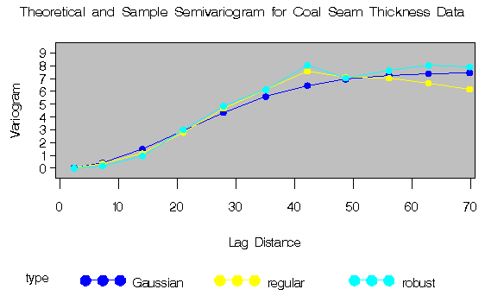

Note that the fit is good, particularly at smaller lag distances. This suggests that the choice of a Gaussian form is adequate. The Gaussian form with the parameter values chosen above can be used in PROC KRIGE2D to produce a contour plot of the kriging estimates and the associated standard errors.

References:

Cliff, AD and Ord, JK (1975). The choice of a test for spatial autocorrelation. In J. C. Davies and M. J. McCullagh (eds) Display and Analysis of Spatial Data, John Wiley and Sons, London, 54-77

Cliff, A. D. and Ord, J. K. 1981 Spatial processes - models and applications. (London: Pion).

Geary, R. (1954). The contiguity ratio and statistical mapping. The Incorporated Statistician 5: pp115-45

Moran, P.A.P. (1950). Notes on continuous stochastic phenomena, Biometrika 37, pp17-23.

Sokal, R.R. and Oden, N.L. (1978). Spatial autocorrelation in biology. 1. Methodology. Biological Journal of the Linnean Society, 10: 199-228.

